

CUSTOMER CHURN
Report

SUMMARY 5
PROJECT BACKGROUND / OBJECTIVES 6
The Problem 6
The Context: 6
OBJECTIVE: 6
DATA SOURCES AND METHODOLOGY. 7
Data Source 7
METHODOLOGY 8
Data Cleaning / Preparation 8
Tools Used 9
EXPLORATORY DATA ANALYSIS 9
Univariate Analysis 10
Bivariate Analysis 10
Correlation Analysis 10
Multivariate Analysis 10
KEY INSIGHTS FROM EDA 11
Importance of EDA 11
ANALYSIS AND VISUALIZATION 11
VISUALIZATION 12
EXPLORATORY ANALYSIS 12
Figure 1: This shows that there are more retented customer than churned customer 13
Figure 2: This shows that ‘Month to Month’ is the most common contract subscription. 14
Figure 3: This shows the number of total Internet service per Contract. 15
Correlation Analysis 15
Figure 4: This shows the count of Tenure per Monthly Charges. 16
Figure 5: This shows the distribution of Total charges per Tenure. 17
UNIVARIATE ANALYSIS 18
Figure 6: This shows the total counts of Tenure. 18
Figure 7: This shows the total counts of Monthly charges. 18
Figure 8: This shows the total counts of Total charges. 19
Figure 9: This shows the total number of retented customers and churned customers. 20
Figure 10: This shows the total number of each contract. 21
Figure 11: This shows the total number of distinct Internet services. 21
Figure 12: This shows the total number of distinct Payment methods. 22
BIVARIATE ANALYSIS 23
Figure 13: This shows the number of churned and retented customers per Contract type. 23
Figure 14: This shows the number of churned and retented customers with respect to Monthly charges. 24
Figure 15: This shows the number of churned and retented customers with respect to Tenure and their Total charges. 25
MULTIVARIATE ANALYSIS 26
Figure 16: This shows the total number of each Contract type per Internet service. 26
Figure 17: This shows the number of churned and retented customers per Tenure, Monthly charges and Total charges. 27
Findings and Recommendations 28
Key Findings 28
Recommendations 28
1. Encourage Long-Term Contracts 28
2. Improve Early Customer Experience 28
3. Optimize Pricing Strategy 29
4. Enhance Fiber Optic Service Quality 29
5. Promote Automatic Payment Methods 29
6. Target High-Risk Segments 29
7. Introduce Loyalty and Retention Programs 29
8. Deploy Predictive Churn Models 29
9. Improve Customer Support Services 29
10. Monitor Churn Continuously 29
Conclusion 29
Challenges and Next Steps 30
Challenges 30
Next Steps 31

SUMMARY
This report combines insights from the uploaded Customer-Churn.csv dataset and the accompanying Customer_Churn_Analysis.ipynb notebook analysis. The study focuses on identifying why customers leave a telecom company (churn) and how predictive analytics can help reduce customer loss.
The customer churn relationship image highlights the major factors influencing why customers leave a telecom company. The overall churn rate is 26.5%, meaning approximately 1 out of every 4 customers discontinued the service.
Customers on month-to-month contracts have the highest churn rate compared to those on one-year or two-year contracts, showing that customers with no long-term commitment are more likely to leave. Similarly, customers with short tenure (0–6 months) are at the highest risk of churn, while churn steadily decreases as customer tenure increases.
Billing also plays a significant role. Customers who churn tend to pay higher monthly charges, suggesting that pricing dissatisfaction may be a key reason for leaving. In addition, customers using electronic check payment methods have the highest churn rate among all payment options.
Service type is another major factor. Customers subscribed to fiber optic internet service churn more than DSL or customers without internet service, which may indicate concerns about pricing, quality, or competition.
Demographic factors also matter. Senior citizens show a higher churn rate than younger customers, while customers without dependents are more likely to leave than those with dependents.
Overall, the analysis shows that the highest-risk customers are those with month-to-month contracts, low tenure, high monthly charges, fiber optic service, electronic payment methods, and senior citizen status. Businesses can reduce churn by targeting these groups with loyalty programs, contract discounts, better service quality, and personalized retention offers.

The dataset contains customer demographics, service subscriptions, contract types, payment methods, billing values, and churn status. Based on exploratory analysis and machine learning models, churn is mainly influenced by:
- Contract type
- Tenure (length of stay)
- Monthly charges
- Internet service type
- Payment method
- Customer support-related services
The notebook also developed classification models such as:
- K-Nearest Neighbors (KNN)
- Decision Tree
- XGBoost
These models can help predict future churn risk.

PROJECT BACKGROUND / OBJECTIVES

The Problem
The business problem addressed in this project was customer churn, which refers to customers discontinuing a company’s service. The key question was: What factors cause customers to leave, and how can the company predict and reduce churn? Understanding the reasons behind churn is essential because losing customers can negatively impact revenue and growth.

The Context:
Customer churn is a major challenge for subscription-based businesses such as telecom companies, banks, insurance firms, and streaming services. Acquiring new customers is often more expensive than retaining existing ones. High churn rates can indicate customer dissatisfaction, pricing issues, poor service quality, or stronger competition in the market. Therefore, analyzing churn helps businesses understand customer behavior, improve service delivery, and remain competitive.

OBJECTIVE:
The expected outcome of this analysis was to identify the key factors influencing customer churn and generate actionable insights for improving customer retention. Specifically, the project aimed to:
• Measure Customer Churn Rate: Determine the percentage of customers who left versus those retained.
• Identify Factors Driving Churn: Analyze how contract type, tenure, monthly charges, payment methods, and services influence churn.
• Understand Customer Behavior: Examine customer usage patterns, preferences, and loyalty trends.
• Segment High-Risk Customers: Identify customers or groups with the highest likelihood of leaving.
• Compare Customer Categories: Evaluate churn differences across gender, senior citizens, dependents, internet type, and contract plans.
• Analyze Revenue Impact: Estimate the financial loss associated with customer churn.
• Improve Retention Strategy: Recommend actions such as loyalty programs, discounts, personalized offers, and service improvements.
• Build Predictive Models: Use machine learning techniques to forecast churn before it happens.
• Support Business Decision-Making: Provide management with insights for pricing, customer care, and long-term planning.
• Increase Customer Lifetime Value: Help the company retain valuable customers for longer periods.
• Enhance Customer Satisfaction: Identify pain points causing dissatisfaction and suggest solutions.
• Reduce Acquisition Costs: Lower the need for expensive new customer acquisition by improving retention.
• Strengthen Competitive Advantage: Enable the company to respond effectively to competitor offers and market challenges.
• Create Monitoring Dashboards: Develop KPIs and dashboards to continuously track churn trends.
• Boost Overall Profitability: Reduce churn-related losses and improve long-term business performance.

DATA SOURCES AND METHODOLOGY.

Data Source
The dataset used for this project was the Customer Churn Dataset, a publicly available dataset commonly used for churn analysis and predictive modeling. It was sourced from Kaggle, which provides real-world business datasets for analytics practice and research. The dataset contains customer demographic information, account details, subscribed services, billing information, and churn status.

METHODOLOGY
The analysis was conducted using a structured data analytics approach. First, the customer churn dataset was collected and reviewed to understand the available variables such as customer demographics, account details, services subscribed to, billing information, and churn status. This helped define the scope of the analysis and identify relevant features.
Next, the dataset was cleaned and prepared by handling missing values, correcting data types, removing duplicate records, and encoding categorical variables into numerical format. Numerical variables such as tenure, monthly charges, and total charges were standardized where necessary to improve analytical accuracy.
After preparation, exploratory data analysis (EDA) was performed using descriptive statistics and visualizations such as bar charts, histograms, boxplots, and heatmaps. This stage helped uncover patterns, trends, and relationships between customer characteristics and churn behavior.
Following the exploratory phase, predictive modeling techniques were applied using machine learning algorithms such as Logistic Regression, K-Nearest Neighbors (KNN), Decision Tree, Random Forest, and XGBoost. These models were trained to classify customers as likely to churn or remain.
Model performance was then evaluated using metrics including accuracy, precision, recall, F1-score, ROC-AUC, and confusion matrix. The best-performing model was selected based on predictive performance.
Finally, the results were interpreted to generate actionable business insights and recommendations aimed at reducing churn, improving customer retention, and increasing profitability.

Data Cleaning / Preparation
The dataset was cleaned to improve quality and accuracy. Missing values in columns such as Total Charges were handled, incorrect data types were corrected, duplicate records were checked, and categorical variables were encoded into numerical values for modeling. Numerical features were also scaled where necessary.
Before analysis, the dataset was cleaned and prepared to ensure accuracy and consistency. The following steps were carried out:
- Handling Missing Values
  - Checked all columns for null or blank values.
  - Missing entries in the Total Charges column were identified and either removed or converted appropriately.
- Changing Data Types
  - Converted Total Charges from text/string format to numeric format for analysis.
  - Verified numerical columns such as tenure and Monthly Charges.
- Removing Duplicates
  - Checked for duplicate customer records to avoid repeated entries.
- Encoding Categorical Variables
  - Converted text variables such as gender, contract type, payment method, and internet service into numerical values using Label Encoding / One-Hot Encoding for machine learning models.
- Feature Scaling
  - Applied normalization or Min-Max Scaling to numerical variables like tenure, Monthly Charges, and Total Charges to improve model performance.
- Data Validation
  - Reviewed column names, value ranges, and consistency of categories.

Tools Used
The following tools and technologies were used throughout the project:
- Python (Pandas, NumPy) – Data cleaning, preprocessing, and manipulation.
- Matplotlib & Seaborn – Data visualization and exploratory data analysis.
- Scikit-learn – Machine learning models such as KNN, Decision Tree, Logistic Regression.
- XGBoost – Advanced predictive churn modeling.
- VsCode – Coding environment for analysis and reporting.
- Excel – Initial data inspection and quick summaries.

EXPLORATORY DATA ANALYSIS
Exploratory Data Analysis (EDA) was conducted to gain a deeper understanding of the customer churn dataset, identify trends, detect inconsistencies, and uncover patterns that explain why customers leave the company. This stage was essential in transforming raw data into meaningful insights before predictive modeling.
The process began with an initial examination of the dataset structure, including the number of rows and columns, variable names, data types, and summary statistics. Missing values, blank entries, and duplicate records were identified and reviewed to ensure data quality. Variables such as Total Charges, Monthly Charges, and tenure were checked for accuracy and consistency.

Univariate Analysis
Univariate analysis was performed to study each variable independently. Numerical variables such as tenure, monthly charges, and total charges were analyzed using descriptive statistics including mean, median, minimum, maximum, and standard deviation. Histograms and boxplots were used to understand distributions, skewness, spread, and the presence of outliers.
Categorical variables such as gender, contract type, internet service, payment method, senior citizen status, dependents, and churn were analyzed using frequency tables, bar charts, and countplots. This helped determine the most common customer categories and the proportion of customers who churned versus those retained.

Bivariate Analysis
Bivariate analysis was carried out to examine the relationship between churn and other variables. This involved comparing churn rates across different customer groups. For example:
- Contract type vs churn
- Payment method vs churn
- Internet service vs churn
- Senior citizen status vs churn
- Dependents vs churn
- Tenure vs churn
- Monthly charges vs churn
Boxplots and grouped bar charts were used to compare churned and retained customers. This analysis revealed that customers on month-to-month contracts, high monthly charges, shorter tenure, and fiber optic internet plans had higher churn rates.

Correlation Analysis
Correlation analysis was conducted on numerical variables such as tenure, monthly charges, and total charges using a correlation matrix and heatmap. This helped measure the strength and direction of relationships among variables. For instance, tenure showed a strong positive relationship with total charges, while monthly charges had moderate relationships with churn-related behavior.

Multivariate Analysis
Multivariate analysis was performed to study the interaction of multiple variables simultaneously. Techniques such as grouped visualizations, pairplots, and segmentation analysis were used to identify complex churn patterns. For example, customers with month-to-month contracts and high monthly charges were found to be at significantly higher risk of churning.

KEY INSIGHTS FROM EDA
The exploratory analysis revealed several important findings:
- Customers with short tenure are more likely to churn.
- Higher monthly charges are associated with increased churn.
- Month-to-month contract customers churn significantly more than long-term contract customers.
- Fiber optic internet users have higher churn compared to DSL users.
- Customers using electronic check payment methods are more likely to leave.
- Senior citizens show relatively higher churn rates.

Importance of EDA
The insights generated during EDA provided the foundation for feature selection, machine learning model development, and strategic recommendations. It ensured a better understanding of customer behavior and helped focus the predictive analysis on the most relevant churn drivers.

ANALYSIS AND VISUALIZATION
The customer churn dataset was analyzed using both statistical techniques and data visualization methods to uncover patterns, trends, and business insights. Visualization played an important role in simplifying complex data and making the findings easier to interpret.
The analysis began with descriptive statistics to summarize key numerical variables such as tenure, monthly charges, and total charges. Measures such as mean, median, standard deviation, minimum, and maximum values were used to understand customer billing behavior and service duration.
Bar charts and count plots were used to visualize categorical variables such as churn status, gender, contract type, payment method, and internet service. These charts helped compare the number of customers in each category and revealed that month-to-month contract customers had the highest churn levels.
Histograms were created for numerical variables to examine their distributions. Tenure showed a concentration of newer customers, while monthly charges displayed a wide range of customer billing amounts. Total charges were positively skewed, indicating that a smaller number of customers had very high lifetime spending.
Boxplots were used to compare churned and retained customers based on numerical variables. The visualizations showed that churned customers generally had lower tenure and higher monthly charges compared to retained customers.
Pie charts and percentage charts were used to display the proportion of churned versus non-churned customers, making it easier to understand the overall churn rate within the company.
Scatter plots were applied to examine relationships between variables such as tenure and total charges. These charts indicated that customers with longer tenure typically generated higher total revenue, while churned customers were concentrated in lower-tenure ranges.
Heatmaps were used for correlation analysis to identify relationships among numerical features. Strong correlations were found between tenure and total charges, while moderate associations existed between monthly charges and churn-related patterns.
Clustered bar charts and stacked charts were used for multivariate analysis, comparing churn across multiple dimensions such as contract type by internet service, payment method by churn, and senior citizen status by churn.
Overall, the visual analysis clearly highlighted that the major churn drivers were short tenure, month-to-month contracts, higher monthly charges, fiber optic internet service, and electronic check payment methods. These insights supported strategic recommendations and predictive modeling.

VISUALIZATION

EXPLORATORY ANALYSIS
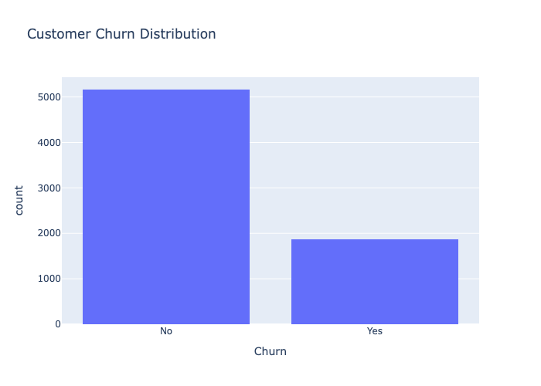

Figure 1: This shows that there are more retented customer than churned customer

Customer Churn Distribution: This histogram illustrates the distribution of customers based on their churn status. It provides a quick overview of the proportion of customers who remained with the company versus those who left, helping identify the extent of customer attrition within the dataset.
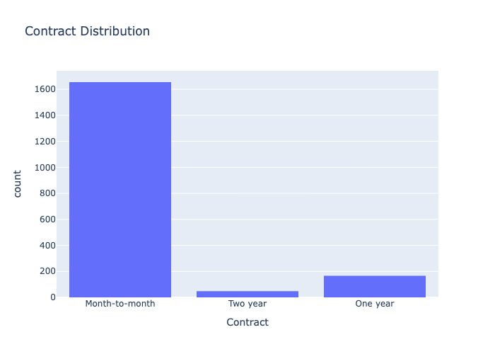

Figure 2: This shows that ‘Month to Month’ is the most common contract subscription.

Contract Distribution: This histogram shows the distribution of customers across different contract types, highlighting which subscription plans are most commonly used in the dataset.

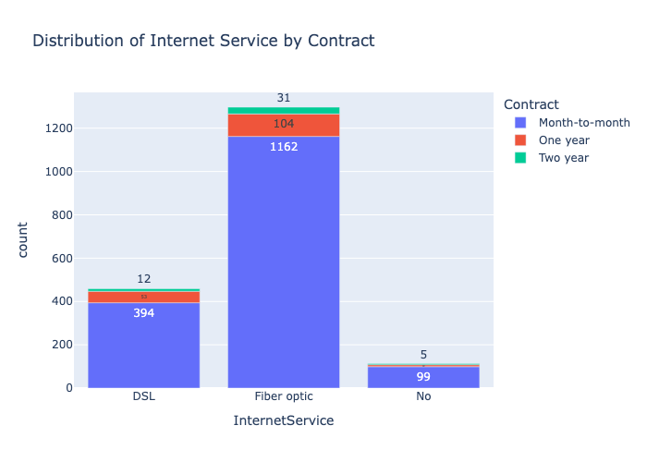

Figure 3: This shows the number of total Internet service per Contract.

Internet Service by Contract: This bar chart shows how different internet service types are distributed across contract categories, helping to reveal patterns in service usage among customer groups.

Correlation Analysis

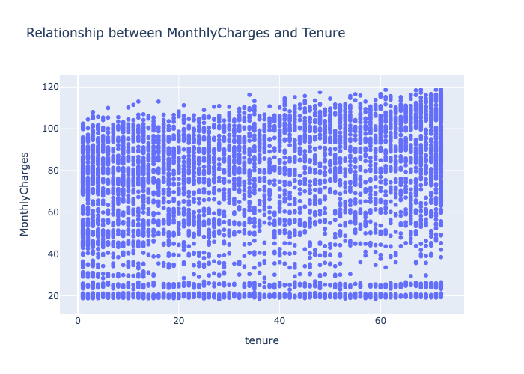

Figure 4: This shows the count of Tenure per Monthly Charges.

Tenure vs Monthly Charges: This scatter plot shows the relationship between customer tenure and monthly charges, helping to identify whether billing amounts vary with the length of time a customer has stayed with the service.

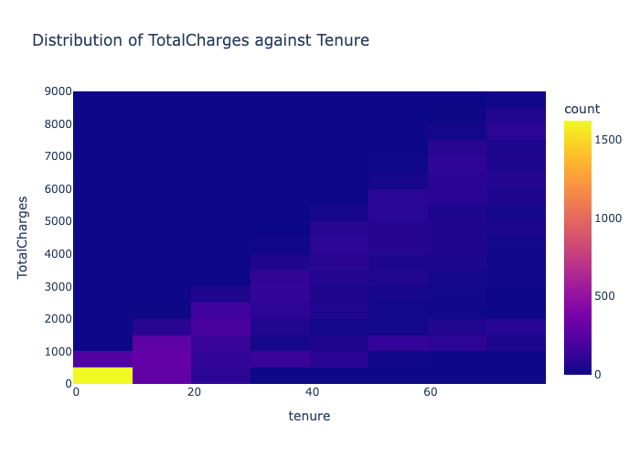

Figure 5: This shows the distribution of Total charges per Tenure.

Total Charges vs Tenure: This heatmap shows the distribution of total charges across customer tenure, highlighting how accumulated charges vary with the length of customer subscription.

UNIVARIATE ANALYSIS
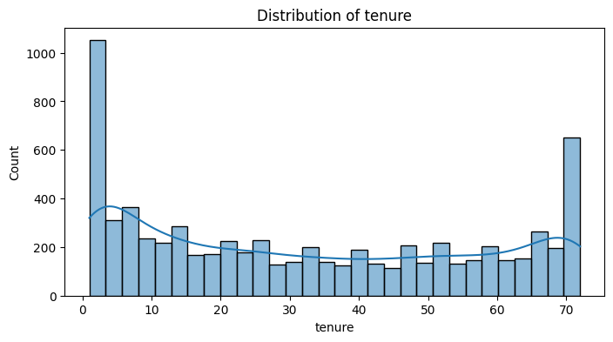

Figure 6: This shows the total counts of Tenure.

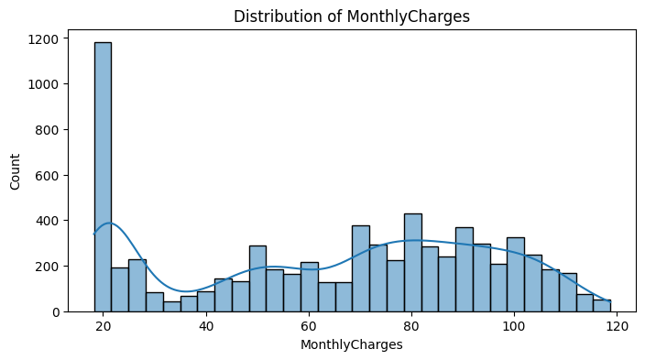

Figure 7: This shows the total counts of Monthly charges.

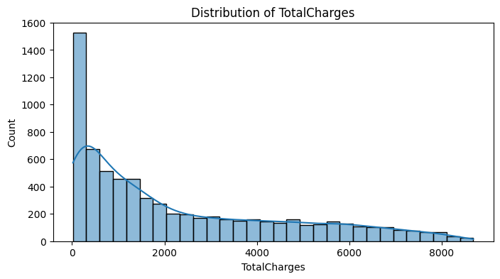

Figure 8: This shows the total counts of Total charges.

Numerical Feature Distributions: This code visualizes the distributions of tenure, monthly charges, and total charges using histograms with KDE, helping to understand the spread and shape of key numerical variables in the dataset.

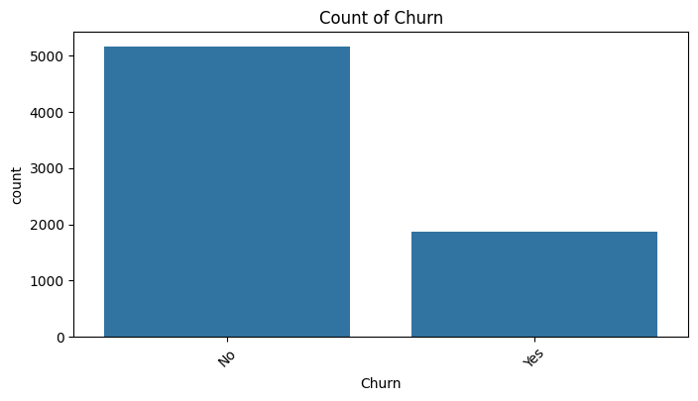

Figure 9: This shows the total number of retented customers and churned customers.
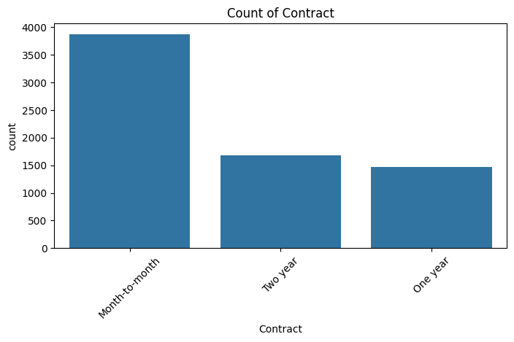

Figure 10: This shows the total number of each contract.
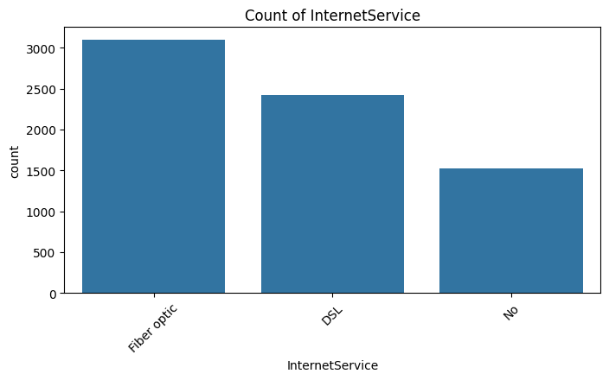

Figure 11: This shows the total number of distinct Internet services.

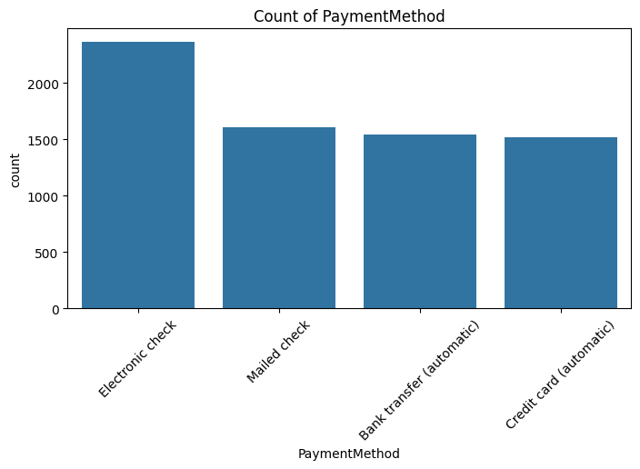

Figure 12: This shows the total number of distinct Payment methods.

Categorical Feature Counts: This loop generates count plots for key categorical variables, showing the frequency distribution of churn status, contract type, internet service, and payment methods in the dataset.

BIVARIATE ANALYSIS
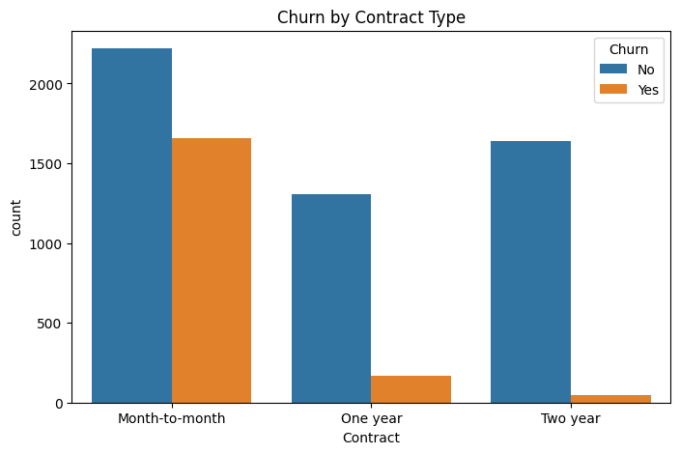

Figure 13: This shows the number of churned and retented customers per Contract type.

Churn by Contract Type: This count plot compares churn status across different contract types, highlighting how customer retention varies depending on the subscription agreement.

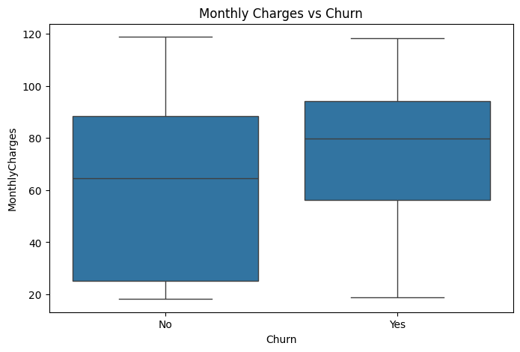

Figure 14: This shows the number of churned and retented customers with respect to Monthly charges.

Monthly Charges vs Churn: This boxplot compares monthly charges between churned and non-churned customers, helping to identify whether pricing levels are associated with customer attrition.

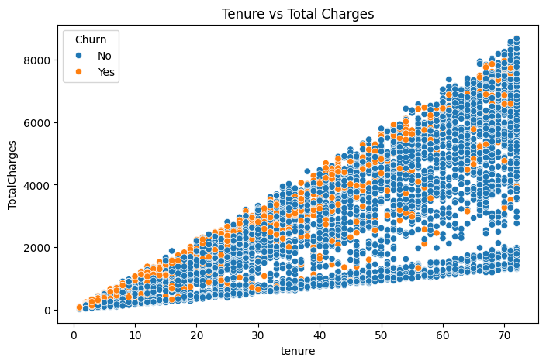

Figure 15: This shows the number of churned and retented customers with respect to Tenure and their Total charges.

Tenure vs Total Charges: This scatter plot shows the relationship between customer tenure and total charges, highlighting how total revenue accumulates as customers remain longer, with churn status indicating retention patterns.

MULTIVARIATE ANALYSIS
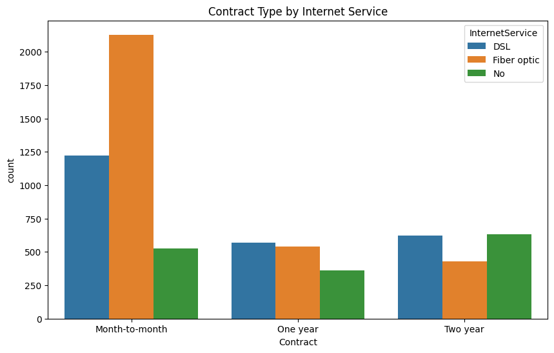

Figure 16: This shows the total number of each Contract type per Internet service.

Contract Type by Internet Service: This count plot shows how different internet service types are distributed across contract categories, helping to reveal service preferences within each contract group.

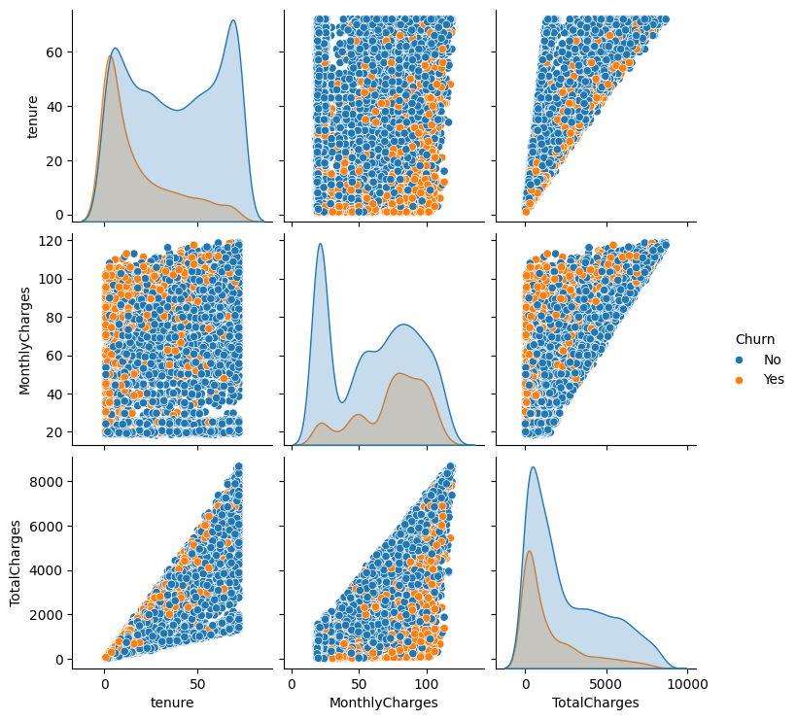

Figure 17: This shows the number of churned and retented customers per Tenure, Monthly charges and Total charges.

Correlation Among Numerical Variables: This pairplot explores relationships between tenure, monthly charges, and total charges, with churn status as the grouping variable to highlight patterns and potential separations between churned and retained customers.

Findings and Recommendations

Key Findings
The analysis revealed several important insights about customer churn:
- High Churn Rate
Approximately 26.5% of customers have churned, indicating a significant retention issue.
- Contract Type is the Strongest Driver
Customers on month-to-month contracts have the highest churn rate, while those on one-year and two-year contracts are far more likely to stay.
- Tenure Influences Loyalty
Customers with short tenure (especially under 6 months) are more likely to churn. Long-term customers show much higher retention.
- Pricing Impact (Monthly Charges)
Customers who churn tend to have higher monthly charges, suggesting price sensitivity or perceived low value for money.
- Internet Service Type
Fiber optic customers show higher churn compared to DSL users, possibly due to cost, service issues, or competition.
- Payment Method Effect
Customers using electronic checks have the highest churn rate, while those using automatic payment methods (bank transfer, credit card) are more stable.
- Customer Demographics
  - Senior citizens have higher churn rates.
  - Customers without dependents are more likely to leave.
- Early Customer Drop-off
A large proportion of churn occurs in the early stages of the customer lifecycle, indicating onboarding or initial experience issues.

Recommendations
Based on these findings, the following strategies are recommended:

1. Encourage Long-Term Contracts
Offer incentives such as discounts, bundled services, or loyalty rewards to move customers from month-to-month plans to one-year or two-year contracts.

2. Improve Early Customer Experience
Focus on the first 3–6 months by providing onboarding support, welcome offers, and proactive customer engagement to reduce early churn.

3. Optimize Pricing Strategy
Review pricing for high monthly charge customers and introduce flexible plans, discounts, or value-added services to improve perceived value.

4. Enhance Fiber Optic Service Quality
Investigate issues related to fiber service such as pricing, speed, reliability, and customer support to reduce dissatisfaction.

5. Promote Automatic Payment Methods
Encourage customers to switch from electronic checks to auto-pay options (bank transfer or card) through incentives or convenience benefits.

6. Target High-Risk Segments
Develop personalized retention campaigns for:
- Short-tenure customers
- Senior citizens
- High-paying customers

7. Introduce Loyalty and Retention Programs
Reward long-term customers with discounts, exclusive offers, or upgraded services to increase retention.

8. Deploy Predictive Churn Models
Use machine learning models (e.g., XGBoost) to identify customers at risk of churning and take proactive action before they leave.

9. Improve Customer Support Services
Strengthen support features such as technical assistance, complaint resolution, and service reliability to improve customer satisfaction.

10. Monitor Churn Continuously
Build dashboards to track churn trends, customer behavior, and retention performance for ongoing decision-making.

Conclusion
This customer churn analysis provided a comprehensive understanding of the factors influencing why customers leave a telecom service. The findings show that churn is not random but driven by clear patterns related to contract type, tenure, pricing, service usage, and payment behavior. Customers on month-to-month contracts, with shorter tenure and higher monthly charges, were identified as the most likely to churn.
The analysis also highlighted that early-stage customers are particularly vulnerable, emphasizing the importance of strong onboarding and early engagement strategies. Additionally, service-related factors such as fiber optic subscriptions and payment methods further contribute to churn risk, indicating areas where the business can improve customer experience and value delivery.
Through exploratory analysis and predictive modeling, the project demonstrated how data can be used not only to understand past churn behavior but also to anticipate future customer decisions. This enables a shift from reactive to proactive retention strategies.
Overall, by implementing targeted interventions such as encouraging long-term contracts, optimizing pricing, improving service quality, and leveraging predictive models, the company can significantly reduce churn, enhance customer satisfaction, and increase long-term profitability.

Challenges and Next Steps

Challenges
- Data Quality Issues
Some inconsistencies were observed in the dataset, such as missing values (e.g., in TotalCharges) and incorrect data types. These require cleaning and may still affect the depth of analysis.
- Limited Feature Scope
The dataset does not include certain important factors like customer complaints, service outages, competitor pricing, or customer satisfaction scores, which could provide deeper insights into churn behavior.
- Class Imbalance
The dataset contains more non-churned customers than churned ones, which can bias machine learning models toward predicting non-churn outcomes.
- Lack of Time-Series Data
The dataset is mostly static and does not capture changes in customer behavior over time, limiting the ability to analyze trends or seasonal churn patterns.
- Model Limitations
While models like Decision Tree and XGBoost perform well, they may still face challenges such as overfitting, interpretability issues, or sensitivity to parameter tuning.
- Generalization Constraints
The dataset represents a specific telecom scenario, so findings may not fully generalize to other industries or regions without adjustments.
- Limited Behavioral Insights
The dataset focuses more on customer attributes rather than detailed behavioral data (e.g., usage frequency, interaction history), which could improve predictive accuracy.

Next Steps
- Collect More Comprehensive Data
Incorporate additional data such as customer feedback, service usage patterns, complaint logs, and competitor information to enrich the analysis.
- Address Class Imbalance
Apply techniques like oversampling (SMOTE), undersampling, or class weighting to improve model performance on churn prediction.
- Enhance Feature Engineering
Create new features such as customer lifetime value, tenure groups, engagement scores, and billing trends to improve predictive power.
- Model Optimization
Perform hyperparameter tuning (e.g., Grid Search, Random Search) to improve the performance of models like XGBoost and Random Forest.
- Deploy Predictive Model
Integrate the churn prediction model into business systems to identify at-risk customers in real time.
- Build Interactive Dashboards
Develop dashboards using Tableau or Power BI to continuously monitor churn trends and key performance indicators.
- Conduct A/B Testing
Test different retention strategies (discounts, offers, communication methods) to determine what works best.
- Incorporate Time-Series Analysis
Track customer behavior over time to understand when and why churn occurs.
- Improve Model Interpretability
Use techniques like feature importance, SHAP values, or LIME to better explain model predictions to stakeholders.
- Implement Retention Campaigns
Use insights from the analysis to design targeted marketing and customer engagement strategies

